
102003/CS500A Computer Networks
COMPUTER NETWORKS RECORD
Submitted in partial fulfillment of the requirements for the award of the degree of
Bachelor of Technology
in
Computer Science and Engineering
Department of Computer Science and Engineering
Rajagiri School of Engineering & Technology (Autonomous)
(Parent University: APJ Abdul Kalam Technological University)
Rajagiri Valley, Kakkanad, Kochi, 682039
September 2026

CERTIFICATE
Certified that this is a Bonafide Record of the work done by ..................................................................................................... in the ..................................................................... Laboratory during the Semester ...................... in the year ................. at Rajagiri School of Engineering & Technology, Rajagiri Valley P.O., Kochi.
Lab-In-Charge Head of the Department
Roll. No. .......................
University Reg. No. ...................
Branch: ..........................................
Submitted for Practical Examination conducted on ...................................
Internal Examiner

Contents
Sl. No. | Name of Experiment | Date | Page No. | Initial of Teacher
1 | Familiarization of Network Configuration Files, Networking Commands, and Shell Scripting in Linux | 18/7/26 | 1
2 | Client-Server Communication using Socket Programming (TCP) | 18/7/26 | 2
3 | Client-Server Communication using Socket Programming (UDP) | 15/7/26 | 6
4 | Implementation of ARQ Flow Control Protocols | 5/8/26 | 10
5 | Implementation and Simulation of Distance Vector Routing Protocol | 19/8/26 | 16
6 | Implementation and Simulation of Leaky Bucket Algorithm | 2/9/26 | 19
7 | Implementation of Simple Mail Transfer Protocol (SMTP) | 9/9/26 | 22
8 | Implementation of File Transfer Protocol (FTP) | 9/9/26 | 26
9 | Introduction to Wireshark Tool | 1/7/26 | 29
10 | Familiarization of NS2 Simulator | 8/7/26 | 30
11 | Study of Packet Tracer | 1/7/26 | 31

Date: 18/7/26
Experiment no 1: Basics of Network Configuration Files and Networking Commands in Linux

Aim:
To familiarize with network configuration files and basic networking commands in Linux and understand their use in configuring, monitoring, and troubleshooting a network.

Linux commands
Linux provides several configuration files and command-line tools for managing network connections. Configuration files contain information such as IP addresses, network interfaces,
DNS settings, and routing details. Common networking commands include:
• ip addr – View IP addresses and network interfaces
• ip route – View and manage routing information
• ping – Test connectivity between two devices
• ifconfig – Display or configure network interfaces
• ss – Display active network connections and listening ports
• nslookup / dig – Query DNS information
• traceroute – Trace the path taken by packets
• hostname – Display or change the system hostname
Students can use these commands to configure, examine, and troubleshoot network connectivity in a Linux environment.

Result:
The basic Linux network configuration files and networking commands were successfully studied and executed. The students gained an understanding of IP configuration, network interfaces, routing, connectivity testing, DNS lookup, and network troubleshooting.

Date: 18/7/26
Experiment no 2: Client-Server Communication using Socket Programming (TCP)

PROGRAM:
TCPServer.java
import java.io.*;
import java.net.*;
public class TCPServer {
public static void main(String[] args) {
try {
ServerSocket serverSocket = new ServerSocket(5000);
System.out.println("Server is listening on port 5000...");
Socket socket = serverSocket.accept();
System.out.println("Client connected.");
BufferedReader in = new BufferedReader(new InputStreamReader
(socket.getInputStream()));
PrintWriter out = new PrintWriter(socket.getOutputStream(), true);
String clientMessage = in.readLine();
System.out.println("Client says: " + clientMessage);
out.println("Hello from Server!");
socket.close();
serverSocket.close();
} catch (IOException e) {
e.printStackTrace();
}
}
}
TCPClient.java
import java.io.*;
import java.net.*;
public class TCPClient {
public static void main(String[] args) {
try {
Socket socket = new Socket("localhost", 5000);
BufferedReader in = new BufferedReader(new InputStreamReader
(socket.getInputStream()));
PrintWriter out = new PrintWriter(socket.getOutputStream(), true);
out.println("Hello from Client!");
String serverMessage = in.readLine();
System.out.println("Server says: " + serverMessage);
socket.close();
} catch (IOException e) {
e.printStackTrace();
}
}
}
OUTPUT:
Server terminal:
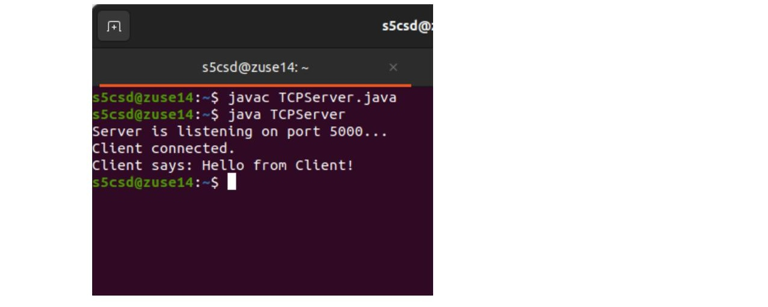
Client terminal:
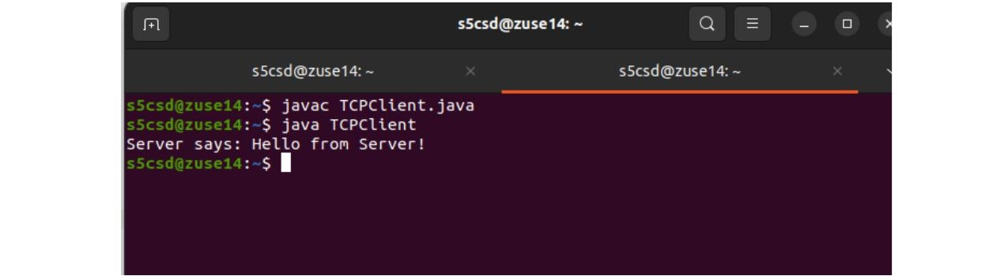
(a) TCP Live Chat Application — Output
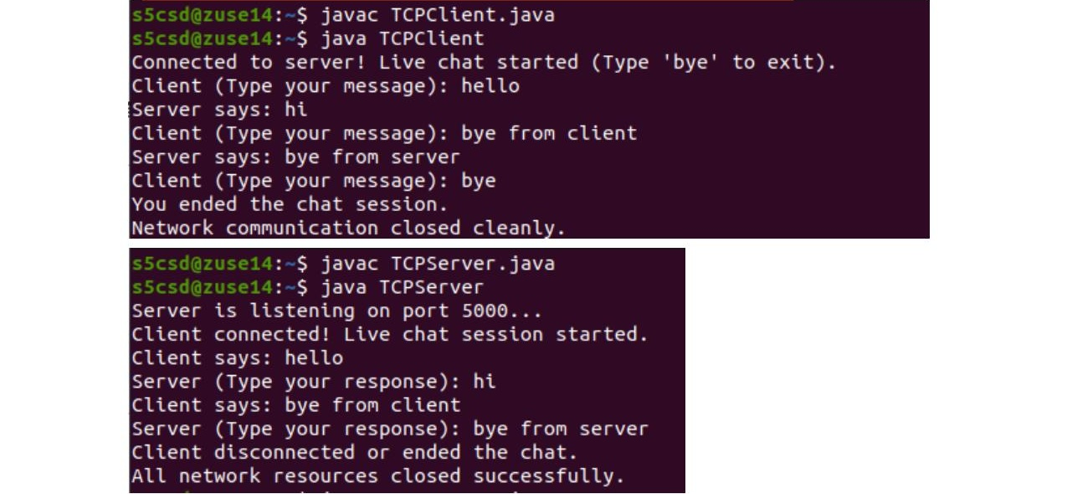
(b) TCP Remote Calculator — Output
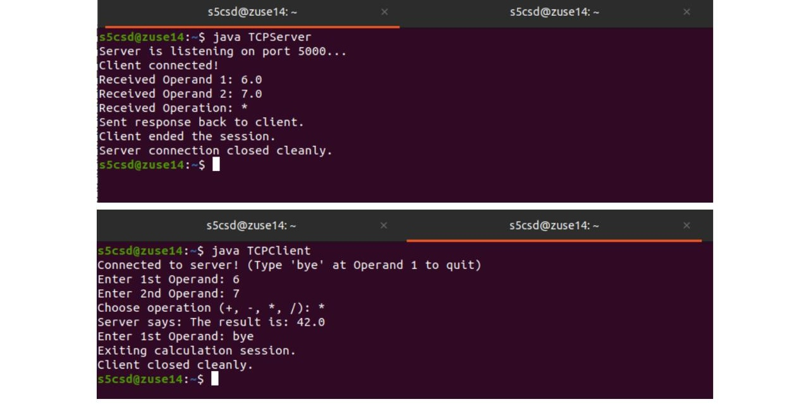

Date: 15/7/26
Experiment no 3: Client-Server Communication using Socket Programming (UDP)

PROGRAM:
UDPClient.java
import java.net.*;
public class UDPClient {
public static void main(String[] args) {
try {
// 1. Create a generic UDP client socket on any available local port
DatagramSocket clientSocket = new DatagramSocket();
// 2. Define the string message and translate it into raw byte data
String message = "Hello from UDP Client!";
byte[] sendData = message.getBytes();
// 3. Resolve the target server's IP address (localhost means this same machine)
InetAddress serverAddress = InetAddress.getByName("localhost");
// 4. Wrap the data, target IP address, and destination server port (9876) into a packet
DatagramPacket sendPacket = new DatagramPacket(sendData, sendData.length, serverAddress, 9876);
// 5. Fire the datagram packet over the network to the server
clientSocket.send(sendPacket);
// 6. Allocate a fresh 1024-byte buffer to catch the server's reply
byte[] receiveData = new byte[1024];
// 7. Establish a placeholder DatagramPacket to structure the incoming reply data
DatagramPacket receivePacket = new DatagramPacket(receiveData, receiveData.length);
// 8. Block and listen until the server transmits a response packet back to this client
clientSocket.receive(receivePacket);
// 9. Extract the data buffer payload, convert it to a string, and strip hidden buffer spaces
String reply = new String(receivePacket.getData()).trim();
System.out.println("Server says: " + reply);
// 10. Close down the client socket cleanly to free up system memory
clientSocket.close();
} catch (Exception e) {
// Print error logging information if the server connection drops or fails
e.printStackTrace();
}
}
}
UDPServer.java
import java.net.*;
public class UDPServer {
public static void main(String[] args) {
try {
// 1. Create a UDP socket bound to port number 9876
DatagramSocket serverSocket = new DatagramSocket(9876);
// 2. Allocate a 1024-byte buffer to store incoming packet data
byte[] receiveData = new byte[1024];
System.out.println("Server is running and waiting for a message...");
// 3. Create a DatagramPacket wrapper to receive the client's payload
DatagramPacket receivePacket = new DatagramPacket(receiveData, receiveData.length);
// 4. This method blocks (waits) until a UDP packet arrives from a client
serverSocket.receive(receivePacket);
// 5. Convert the received bytes into a String and trim trailing empty spaces
String clientMessage = new String(receivePacket.getData()).trim();
System.out.println("Client says: " + clientMessage);
// 6. Extract the client's network metadata (IP address and communication port)
// This is required because UDP is connectionless; the server must find out where to reply.
InetAddress clientAddress = receivePacket.getAddress();
int clientPort = receivePacket.getPort();
// 7. Prepare the outbound reply and convert it to raw bytes
String reply = "Hello from UDP Server!";
byte[] sendData = reply.getBytes();
// 8. Package the response data along with the client's destination IP and Port
DatagramPacket sendPacket = new DatagramPacket(sendData, sendData.length, clientAddress, clientPort);
// 9. Transmit the packet back across the network to the client
serverSocket.send(sendPacket);
// 10. Release system resources by closing the server socket
serverSocket.close();
} catch (Exception e) {
// Print details of any exception or network error that occurs
e.printStackTrace();
}
}
}
OUTPUT:
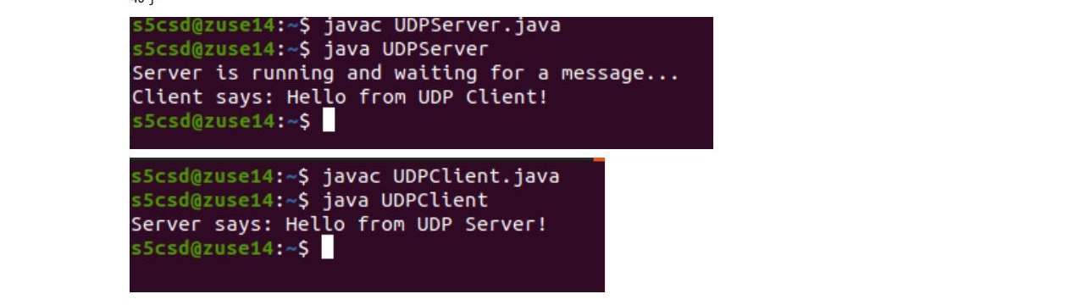

Date: 5/8/26
Experiment no 4: Implementation of ARQ Flow Control Protocols

PROGRAM:
StopAndWaitARQ.java
import java.util.Scanner;
public class StopAndWaitARQ {
public static void main(String[] args) {
Scanner sc = new Scanner(System.in);
System.out.print("Enter number of frames: ");
int n = sc.nextInt();
for (int i = 1; i <= n; i++) {
System.out.println("\nSending Frame " + i);
System.out.print("Enter ACK (1 = Received, 0 = Lost): ");
int ack = sc.nextInt();
while (ack == 0) {
System.out.println("ACK Lost! Resending Frame " + i);
System.out.print("Enter ACK (1 = Received, 0 = Lost): ");
ack = sc.nextInt();
}
System.out.println("ACK Received for Frame " + i);
}
System.out.println("\nAll Frames Sent Successfully.");
sc.close();
}
}
GoBackNARQ.java
import java.util.Scanner;
public class GoBackNARQ {
public static void main(String[] args) {
Scanner sc = new Scanner(System.in);
System.out.print("Enter number of frames: ");
int n = sc.nextInt();
System.out.print("Enter window size: ");
int window = sc.nextInt();
int i = 1;
while (i <= n) {
int start = i;
System.out.print("\nSending Frames: ");
for (int j = 0; j < window && (i + j) <= n; j++) {
System.out.print((i + j) + " ");
}
System.out.print("\nEnter ACK (1 = Success, 0 = Failure): ");
int ack = sc.nextInt();
if (ack == 1) {
System.out.println("All Frames Acknowledged.");
i += window;
} else {
System.out.println("Frame Lost! Resending from Frame " + start);
}
}
System.out.println("\nTransmission Completed.");
sc.close();
}
}
SelectiveRepeatARQ.java
import java.util.Scanner;
public class SelectiveRepeatARQ {
public static void main(String[] args) {
Scanner sc = new Scanner(System.in);
System.out.print("Enter number of frames: ");
int n = sc.nextInt();
int[] ack = new int[n + 1];
for (int i = 1; i <= n; i++) {
System.out.println("\nSending Frame " + i);
System.out.print("Enter ACK (1 = Received, 0 = Lost): ");
ack[i] = sc.nextInt();
}
System.out.println("\nChecking Lost Frames...");
for (int i = 1; i <= n; i++) {
if (ack[i] == 0) {
System.out.println("Resending Frame " + i);
System.out.print("Enter ACK after resend (1 = Received): ");
ack[i] = sc.nextInt();
}
}
System.out.println("\nAll Frames Successfully Received.");
sc.close();
}
}
OUTPUT:
StopAndWaitARQ.java
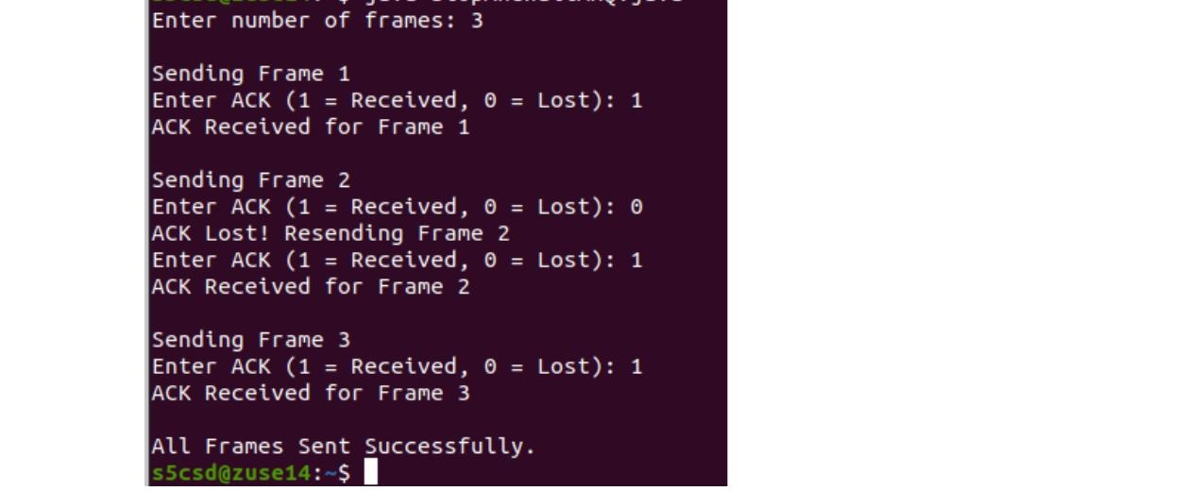
GoBackNARQ.java
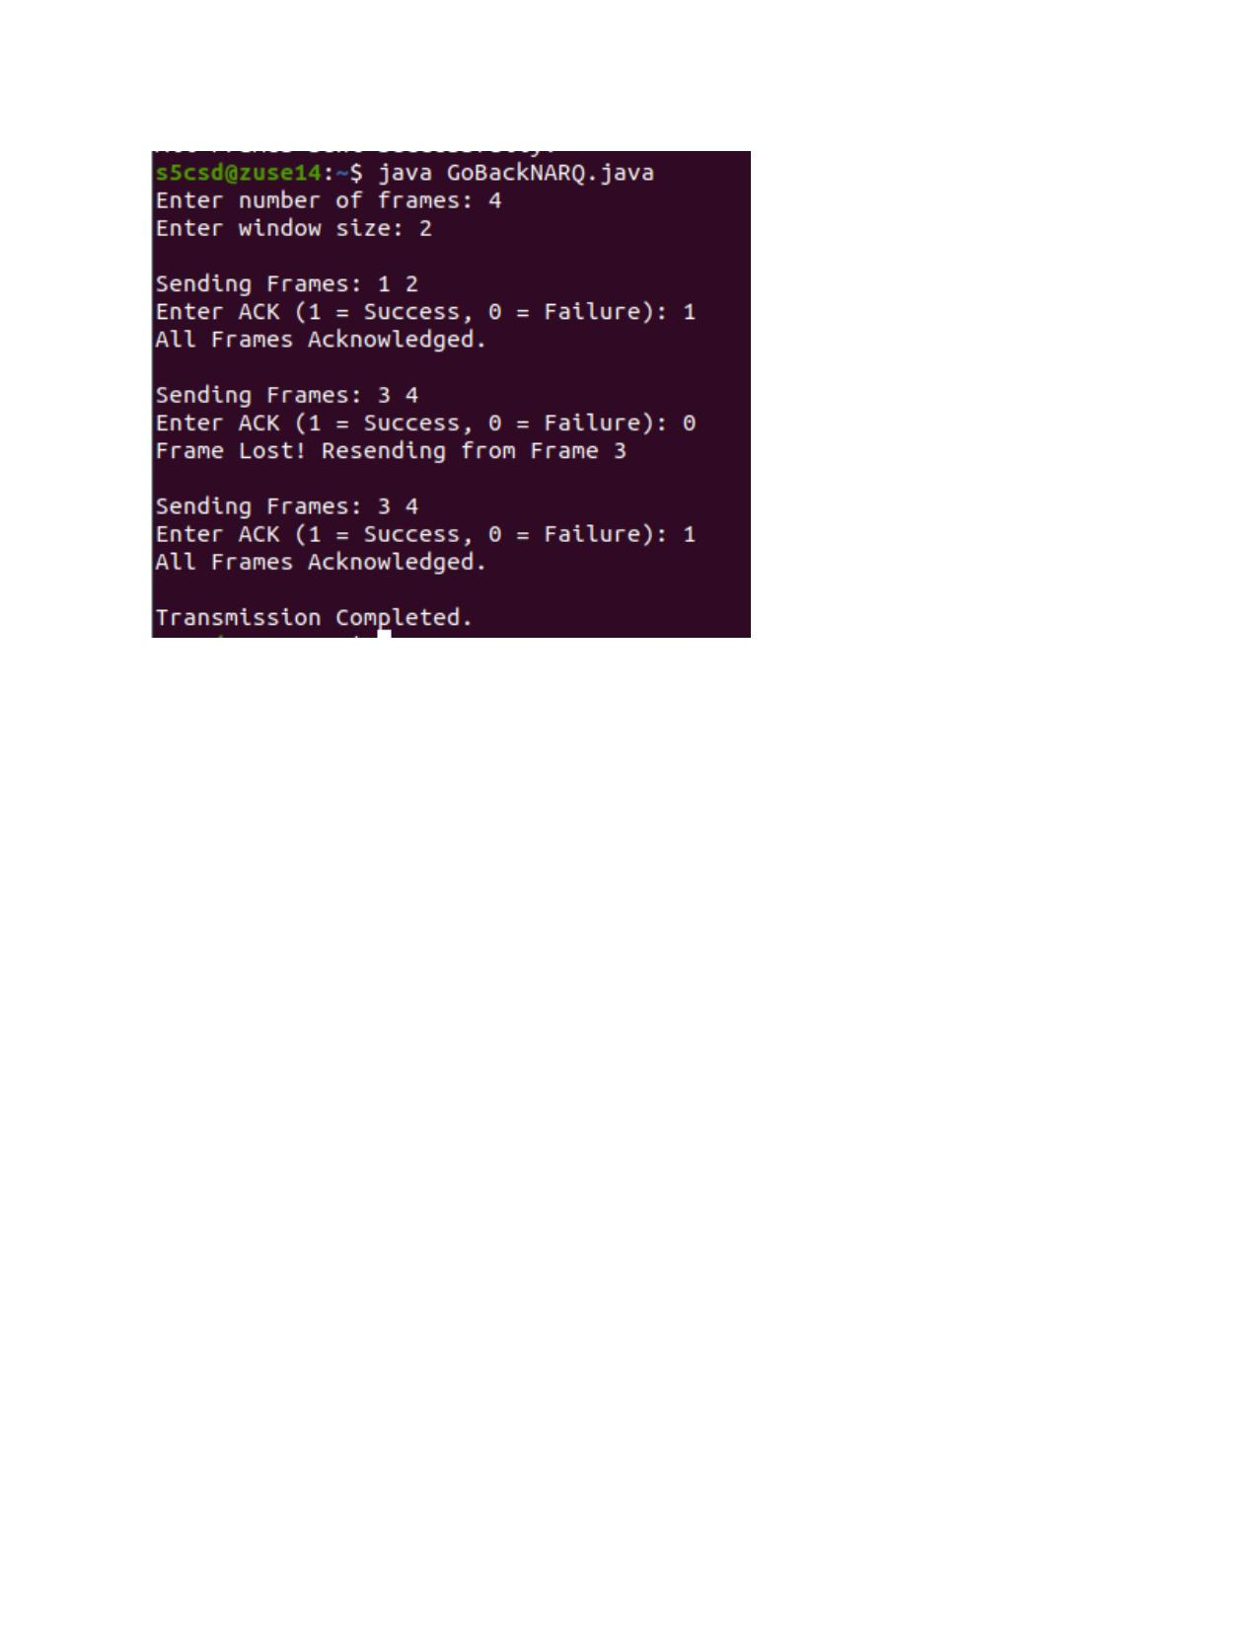
SelectiveRepeatARQ.java
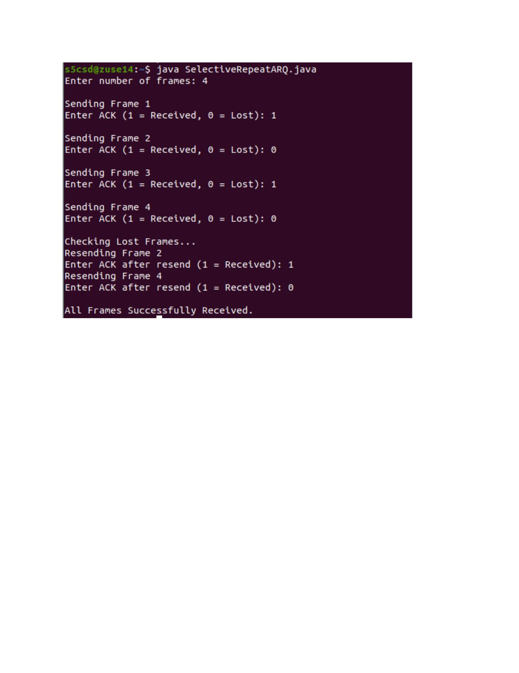

Date: 19/8/26
Experiment no 5: Implementation and Simulation of Distance Vector Routing Protocol

PROGRAM:
DistanceVector.java
import java.util.Scanner;
public class DistanceVector{
public static void main(String[] args){
Scanner sc=new Scanner(System.in);
int routers;
System.out.print("Enter the number of routers: ");
routers=sc.nextInt();
int[][] cost=new int[routers][routers];
int[][] distance=new int[routers][routers];
int[][] nextHop=new int[routers][routers];
System.out.println("Enter the Cost Matrix (Use 999 for Infinity):");
for (int i=0;i<routers;i++){
for (int j=0;j<routers;j++){
cost[i][j]=sc.nextInt();
distance[i][j]=cost[i][j];
if (i==j)
nextHop[i][j]=i;
else
nextHop[i][j]=j;
}
}
for (int k=0;k<routers;k++){
for (int i=0;i<routers;i++){
for (int j=0;j<routers;j++){
if (distance[i][k]+distance[k][j] < distance[i][j]){
distance[i][j]=distance[i][k]+distance[k][j];
nextHop[i][j]=nextHop[i][k];
}
}
}
}
for (int i=0;i<routers;i++){
System.out.println("\nRouting Table for Router "+i);
System.out.println("------------------------------------------");
System.out.println("Destination\tNext Hop\tCost");
for (int j=0;j<routers;j++){
System.out.println(j + "\t\t" + nextHop[i][j] + "\t\t" + distance[i][j]);
}
}
sc.close();
}
}
OUTPUT:
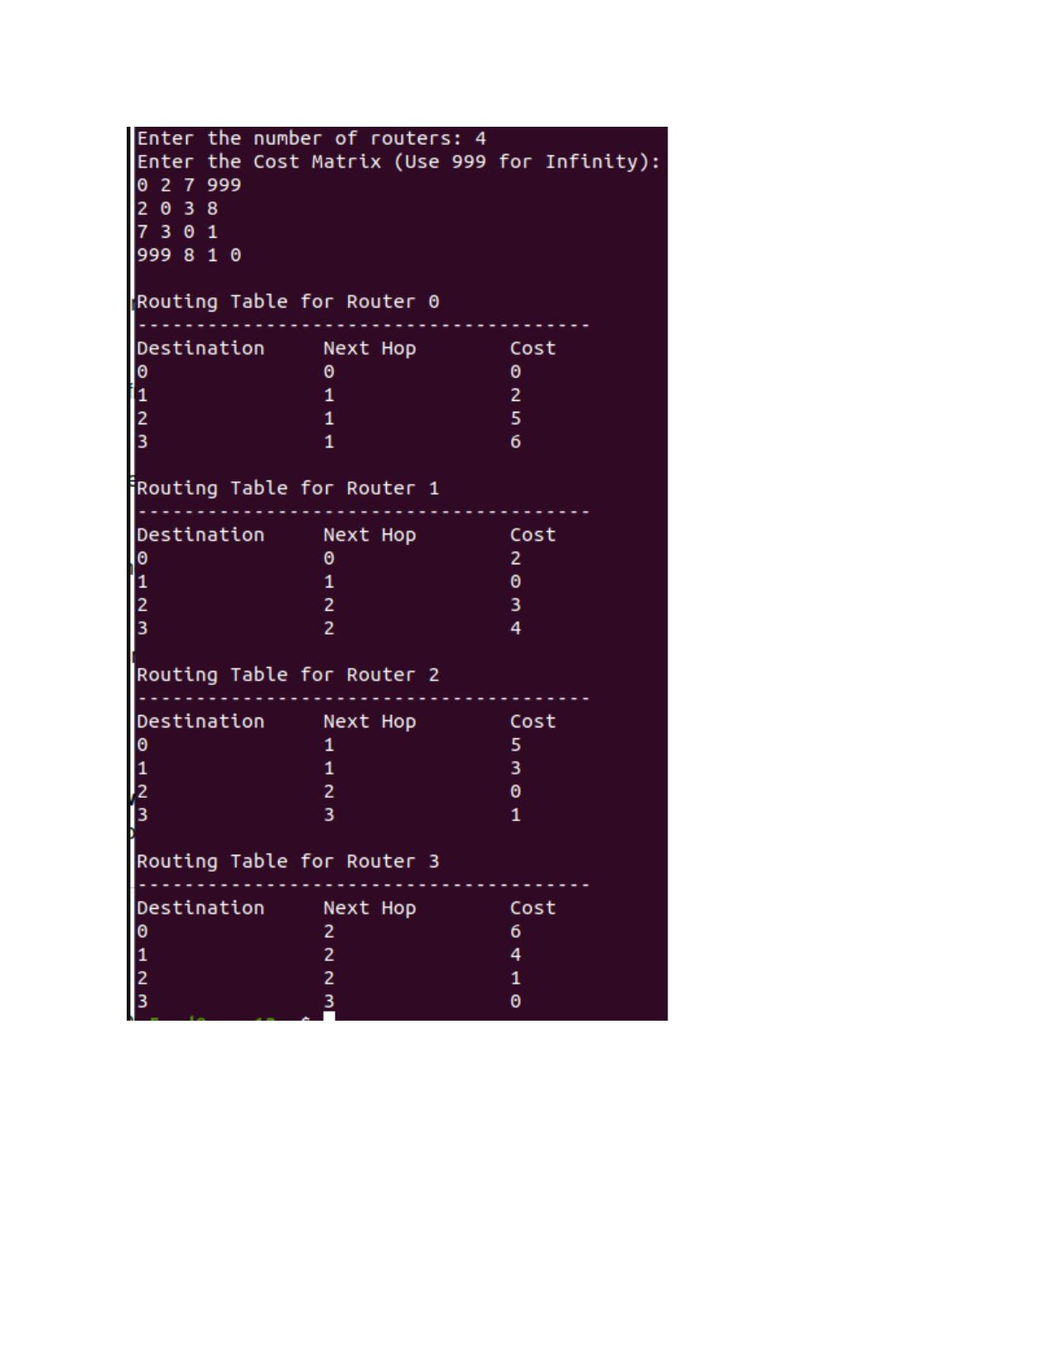

Date: 2/9/26
Experiment no 6: Implementation and Simulation of Leaky Bucket Algorithm

PROGRAM:
LeakyBucket.java
import java.util.Scanner;
public class LeakyBucket {
public static void main(String[] args) {
Scanner sc = new Scanner(System.in);
int bucketSize, outputRate;
int stored = 0, resend = 0;
System.out.print("Bucket size: ");
bucketSize = sc.nextInt();
System.out.print("Output rate: ");
outputRate = sc.nextInt();
System.out.print("Number of packet batches: ");
int n = sc.nextInt();
for (int i = 1; i <= n; i++) {
System.out.print("Incoming packets: ");
int packets = sc.nextInt();
packets = packets + resend;
resend = 0;
int space = bucketSize - stored;
if (packets <= space) {
stored = stored + packets;
} else {
stored = bucketSize;
resend = packets - space;
System.out.println("Overflow packets: " + resend);
System.out.println("Overflow packets will be resent.");
}
int transmitted;
if (stored >= outputRate) {
transmitted = outputRate;
} else {
transmitted = stored;
}
stored = stored - transmitted;
System.out.println("Packets transmitted: " + transmitted);
System.out.println("Packets in bucket: " + stored);
if (resend > 0) {
System.out.println("Packets waiting for resend: " + resend);
}
System.out.println();
}
while (resend > 0) {
int space = bucketSize - stored;
if (resend <= space) {
stored = stored + resend;
resend = 0;
} else {
stored = bucketSize;
resend = resend - space;
}
int transmitted;
if (stored >= outputRate) {
transmitted = outputRate;
} else {
transmitted = stored;
}
stored = stored - transmitted;
System.out.println("Resent packets transmitted: " + transmitted);
}
sc.close();
}
}
OUTPUT:
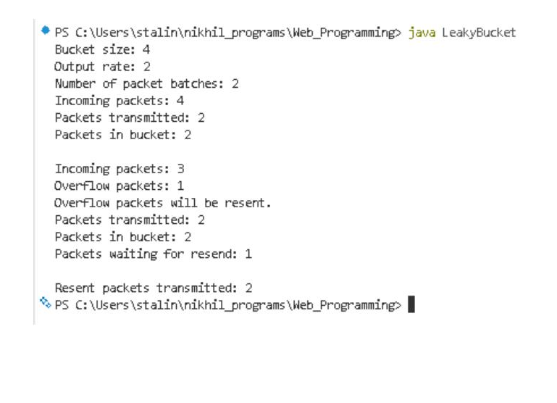

Date: 9/9/26
Experiment no 7: Implementation of Simple Mail Transfer Protocol (SMTP)

PROGRAM:
SmtpServer.java
import java.io.*;
import java.net.*;
public class SmtpServer {
public static void main(String[] args) {
int port = 2525;
try (ServerSocket serverSocket = new ServerSocket(port)) {
System.out.println("SMTP Server started on port " + port);
System.out.println("Waiting for client...");
Socket socket = serverSocket.accept();
System.out.println("Client connected!");
BufferedReader in = new BufferedReader(
new InputStreamReader(socket.getInputStream()));
PrintWriter out = new PrintWriter(
socket.getOutputStream(), true);
// SMTP greeting
out.println("220 localhost SMTP Server Ready");
String command;
while ((command = in.readLine()) != null) {
System.out.println("Client: " + command);
if (command.startsWith("HELO")) {
out.println("250 Hello");
}
else if (command.startsWith("MAIL FROM")) {
out.println("250 Sender OK");
}
else if (command.startsWith("RCPT TO")) {
out.println("250 Recipient OK");
}
else if (command.equals("DATA")) {
out.println("354 Start mail input");
while ((command = in.readLine()) != null) {
System.out.println("Client: " + command);
if (command.equals(".")) {
out.println("250 Message accepted");
break;
}
}
}
else if (command.equals("QUIT")) {
out.println("221 Bye");
break;
}
}
socket.close();
} catch (IOException e) {
System.out.println("Server Error: " + e.getMessage());
}
}
}
SmtpClient.java
import java.io.*;
import java.net.*;
public class SmtpClient {
public static void main(String[] args) {
String server = "localhost";
int port = 2525;
try (Socket socket = new Socket(server, port)) {
BufferedReader in = new BufferedReader(
new InputStreamReader(socket.getInputStream()));
PrintWriter out = new PrintWriter(
socket.getOutputStream(), true);
// Read server greeting
System.out.println("Server: " + in.readLine());
// HELO
out.println("HELO localhost");
System.out.println("Server: " + in.readLine());
// MAIL FROM
out.println("MAIL FROM:<sender@example.com>");
System.out.println("Server: " + in.readLine());
// RCPT TO
out.println("RCPT TO:<receiver@example.com>");
System.out.println("Server: " + in.readLine());
// DATA
out.println("DATA");
System.out.println("Server: " + in.readLine());
// Email
out.println("From: sender@example.com");
out.println("To: receiver@example.com");
out.println("Subject: SMTP Test");
out.println();
out.println("Hello! This is an email sent using SMTP.");
out.println("This program uses Java Socket programming.");
// End of message
out.println(".");
System.out.println("Server: " + in.readLine());
// QUIT
out.println("QUIT");
System.out.println("Server: " + in.readLine());
} catch (IOException e) {
System.out.println("Client Error: " + e.getMessage());
}
}
}
OUTPUT:
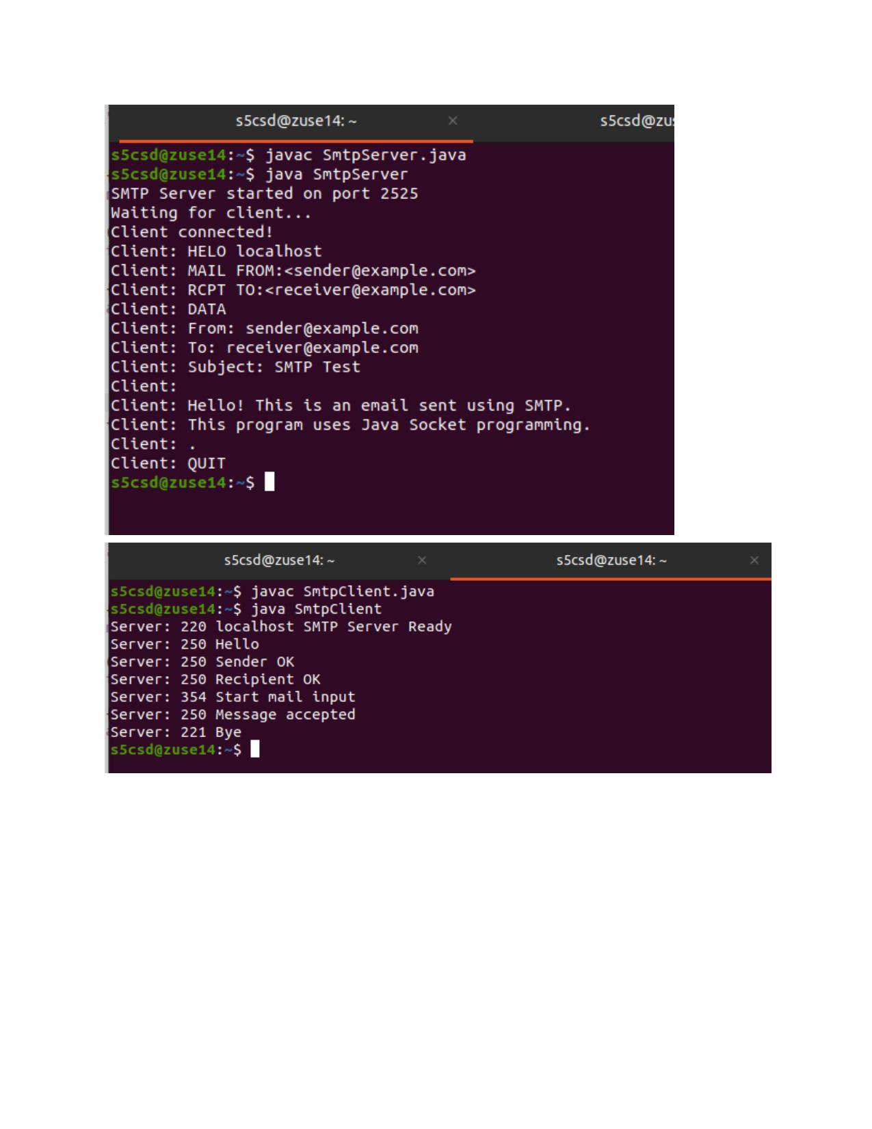

Date: 9/9/26
Experiment no 8: Implementation of File Transfer Protocol (FTP)

PROGRAM:
FTPServer.java
import java.io.*;
import java.net.*;
public class FTPServer {
public static void main(String[] args) throws Exception {
ServerSocket ss = new ServerSocket(5000);
System.out.println("Server started...");
System.out.println("Waiting for client...");
Socket s = ss.accept();
System.out.println("Client connected.");
DataInputStream dis = new DataInputStream(s.getInputStream());
String fileName = dis.readUTF();
System.out.println("Receiving file: " + fileName);
FileOutputStream fos =
new FileOutputStream("received_" + fileName);
byte[] buffer = new byte[4096];
int bytesRead;
while ((bytesRead = dis.read(buffer)) != -1) {
fos.write(buffer, 0, bytesRead);
}
fos.close();
dis.close();
s.close();
ss.close();
System.out.println("File received successfully.");
}
}
FTPClient.java
import java.io.*;
import java.net.*;
public class FTPClient {
public static void main(String[] args) throws Exception {
Socket s = new Socket("localhost", 5000);
DataOutputStream dos = new DataOutputStream(s.getOutputStream());
File file = new File("test.txt");
dos.writeUTF(file.getName());
FileInputStream fis = new FileInputStream(file);
byte[] buffer = new byte[4096];
int bytesRead;
while ((bytesRead = fis.read(buffer)) != -1) {
dos.write(buffer, 0, bytesRead);
}
fis.close();
dos.close();
s.close();
System.out.println("File sent successfully.");
}
}
OUTPUT:
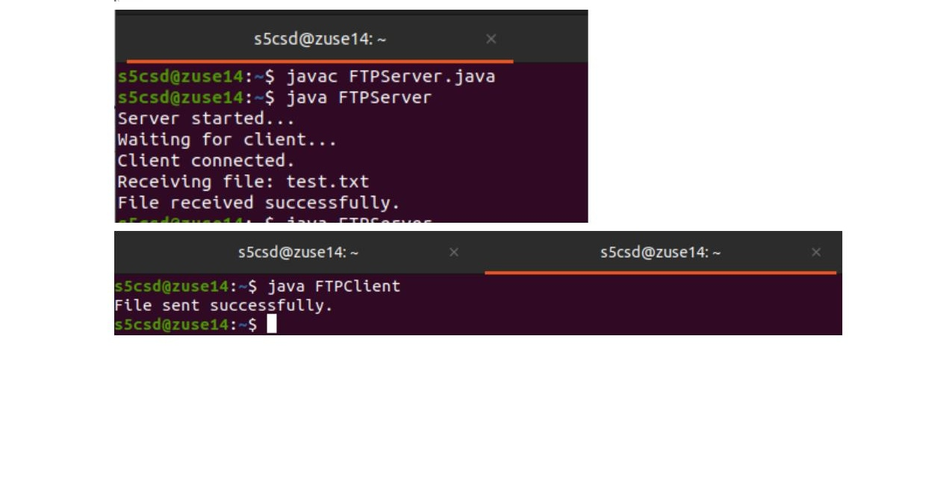

Date: 1/7/26
Experiment no 9: Introduction to Wireshark Tool

Aim:
To familiarize with the Wireshark network protocol analyzer and learn to capture, filter, and analyze network packets and protocol information.

Wireshark
Wireshark is a free and open-source network protocol analyzer used to capture and analyze network packets. It helps us understand what happens to data as it travels through a network.
Functionalities
Packet Capture: Captures packets transmitted and received by a computer.
Protocol Analysis: Allows us to examine protocols such as TCP, UDP, HTTP, DNS, ICMP, etc.
Packet Details: Shows information such as source IP, destination IP, port numbers, packet length, and protocol.
Filtering: Filters can be used to display only the packets of interest, such as tcp, udp, or icmp.
Troubleshooting: Helps identify network problems such as packet loss, retransmissions, and connection failures.
Learning Tool: Useful for understanding how network protocols work in real-world communication.

Result:
Wireshark was successfully explored, and network packets were captured and analyzed using suitable filters. The students gained an understanding of packet details and different network protocols.

Date: 8/7/26
Experiment no 10: Familiarization of NS2 Simulator

Aim:
To familiarize with the NS2 network simulator and understand the creation, simulation, and analysis of a basic computer network using Tcl scripts.
NS2
NS2 (Network Simulator 2) is a discrete-event network simulation tool used to design, simulate, and analyze computer networks. It allows students to study how different network protocols behave without requiring a real physical network.
Network Simulation: Creates virtual network topologies with nodes, links, and connections.
Protocol Study: Used to study protocols such as TCP, UDP, routing protocols, and MAC protocols.
Tcl Scripts: Network scenarios are generally created using Tcl scripts.
NAM: Network Animator (NAM) can be used to visually observe packet transmission and network activity.
Trace Files: NS2 generates trace files containing information about packet transmission, reception, and loss.

Performance Analysis: Metrics such as throughput, packet loss, delay, and packet delivery ratio can be analyzed.

Result:
NS2 was successfully explored, and a basic network simulation was performed. The students gained an understanding of network topology, packet transmission, trace files, and network performance analysis.

Date: 1/7/26
Experiment no 11: Cisco Packet Tracer

Aim:
To familiarize with Cisco Packet Tracer and learn to create, configure, and test basic computer networks using virtual networking devices.

Packet Tracer
Cisco Packet Tracer is a network simulation tool used to create virtual networks without requiring physical networking hardware. It provides devices such as routers, switches, PCs, and servers that can be connected and configured. Students can assign IP addresses, configure network devices, test connectivity using commands such as ping, and observe how packets travel through the network.

Result:
Cisco Packet Tracer was successfully explored, and a basic network was created and configured. Connectivity between network devices was tested successfully, providing an understanding of network topology, IP addressing, device configuration, and packet transmission.

